Overall, the results seem logical. The majority of our errors during the target time widow are classified as phonological. The majority of errors during the production window are offset. The phonological errors are interspersed and may be due to incomplete perceptual information (e.g., the stimulator induces "noise" into the acoustic-physiological trace so they get some perceptual information). The best patient appears to be A97 - she has the most clean stimulations throughout specific time windows. As of right now, it is difficult to ascertain whether there is a difference between middle STG sites and posterior STG sites - maybe your results will elucidate this more?

**A80 - Megan Murphy (MRN: 52502489) - sx date: 1/23/2012** 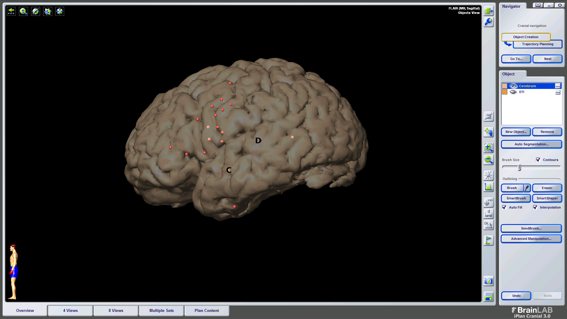

* Patient not given the delay paradigm due to behavioral issues intra-operatively
* of note: the location of 'C' is a little odd...it is kind of in the superior temporal sulcus/middle temporal gyrus - it is below where we typically find our sites that cluster in that area; 'D' looks appropriate for a typical posterior STG site

**A97 - Keely Paregian (MRN: 53074405) - sx date: 4/30/2012**

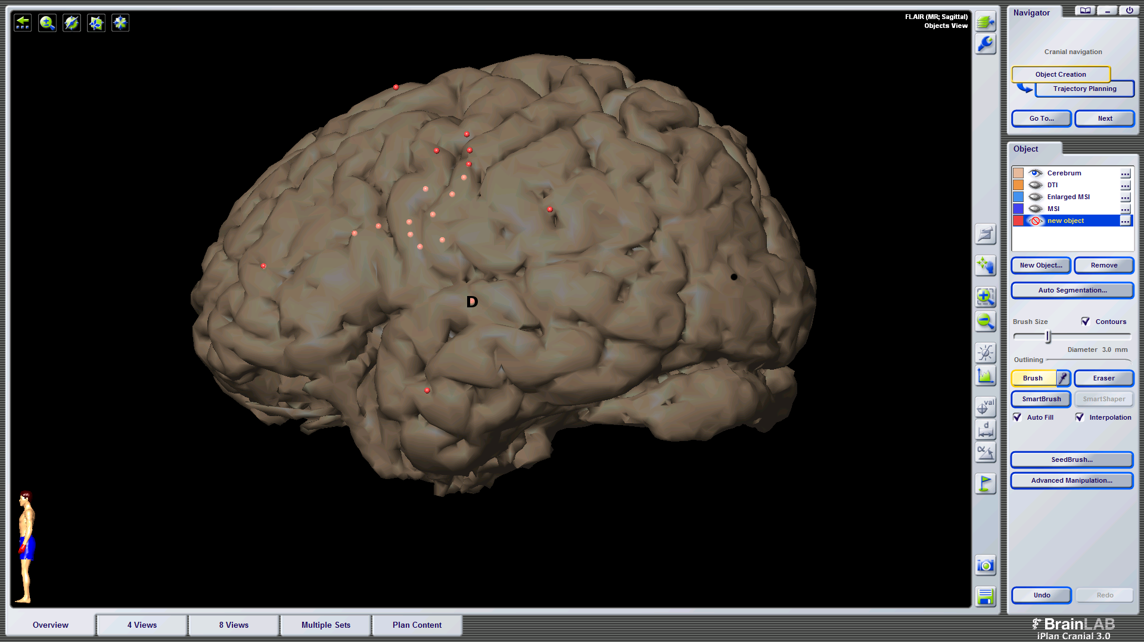

9 trials w/ stimulation during target presentation only

a. 4/9 trials caused errors

a. 3 perceptual errors, "I didn't understand it", 1 real word substitution (native -> negative)

6 trials stimulation during buffer window only

a. no errors during buffer period

9 trials w/ stimulation during production window only (1 additional trial with partial stim during buffer)

a. 2/9 trials caused errors

a. classified as phonological errors. these were non-word responses that seemed to be affected by poor phonological selection or altered output during disrupted feedback (e.g, velocity -> velositivity; delivery -> deliverty...deliver...something like that)

**A101 - Nancy Raynes (MRN: 53074405) - sx date: 7/2/2012**

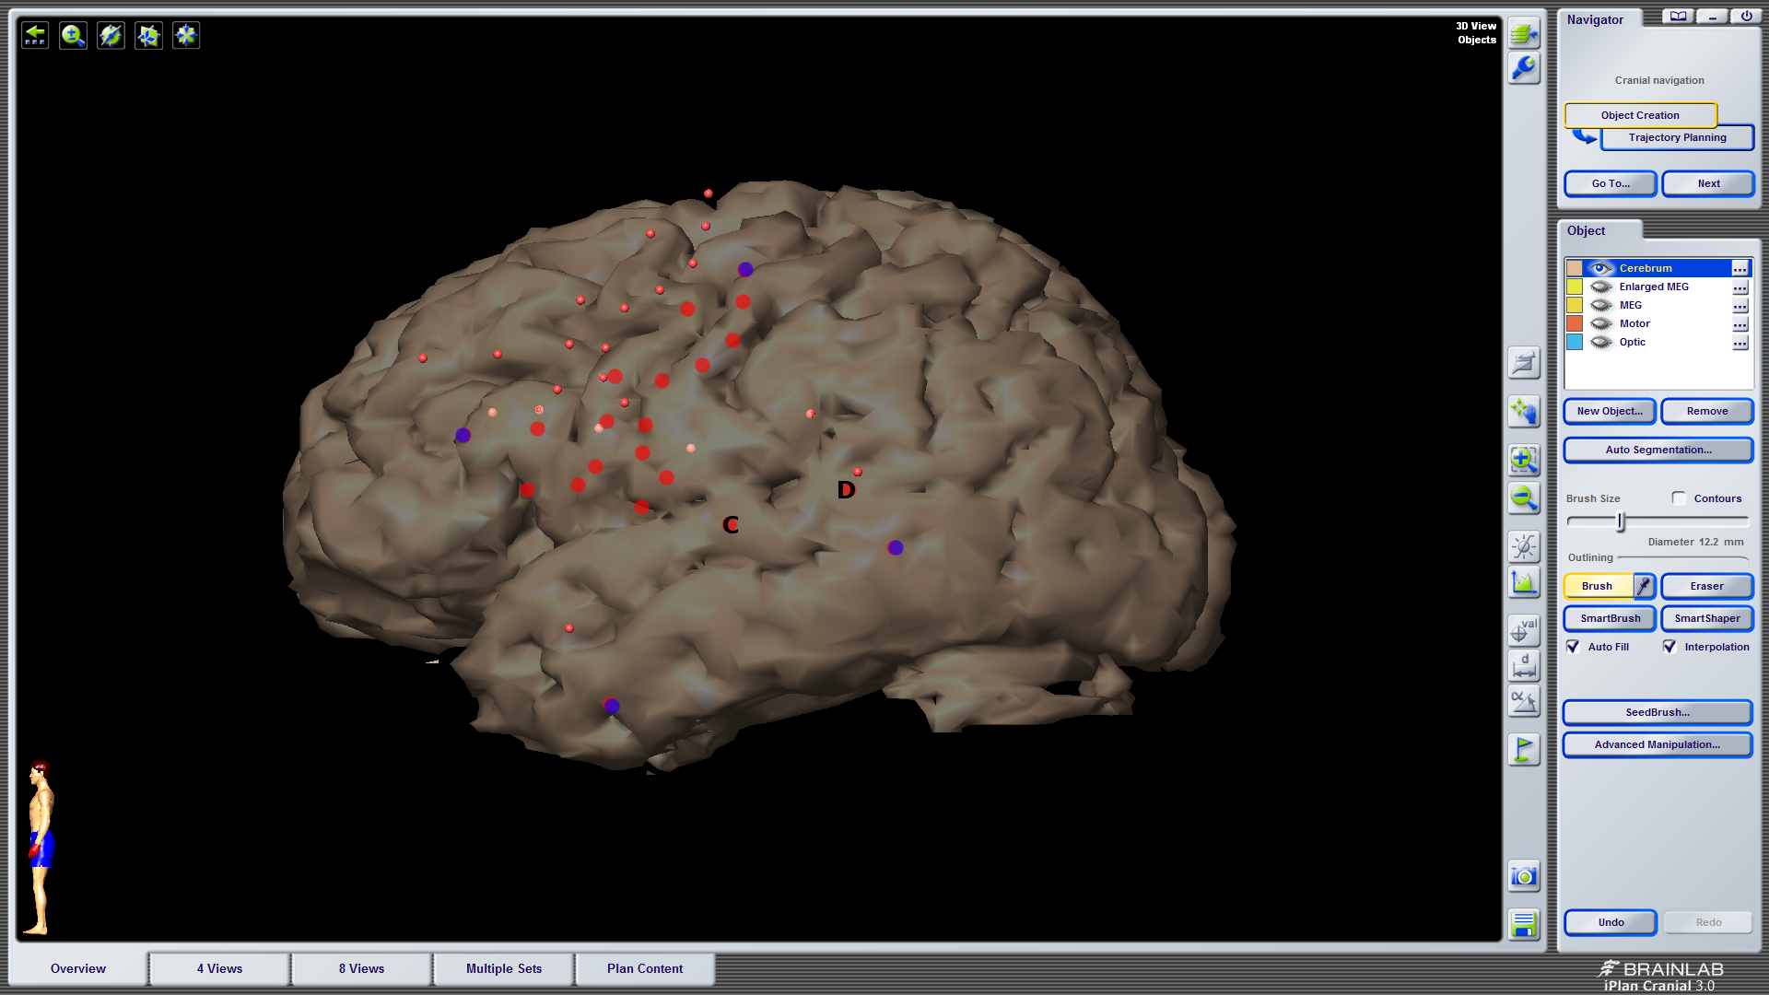

**SITE 'C'**

3 trials w/ stimulation during target window only (2 additional trials w/ bleedover into buffer window)

a. 1/3 trials caused error (1 bleedover trial classified as an error)

a. error classified as perceptual (bleedover error classified as perceptual)

0 trials w/ stimulation during buffer window only

1 trial w/ stimulation during production window only (1 w/ partial stimulation during buffer window)

a. 0 errors (1 error during partial stimulation trial - classified as offset error)

**SITE 'D'**

1 trial w/ stimulation during target window only

a. 1/1 trials caused error - classified as perceptual error, "i don't know"

4 trials w/ stimulation during buffer window only (3 addition trials w/ bleedover)

a. 0/4 trials w/ error (1/3 trials w/ error - classified as offset error)

2 trials w/ stimulation during production window only

a. 1/2 trials w/ error - classified as phonological error

a. of note: the target was motive and the patient said "moutuh" and then self-corrected and said

"motive" at the stimulation offset

A103 - Maximo Galindo (MRN: 53217516) - sx date: 7/23/12

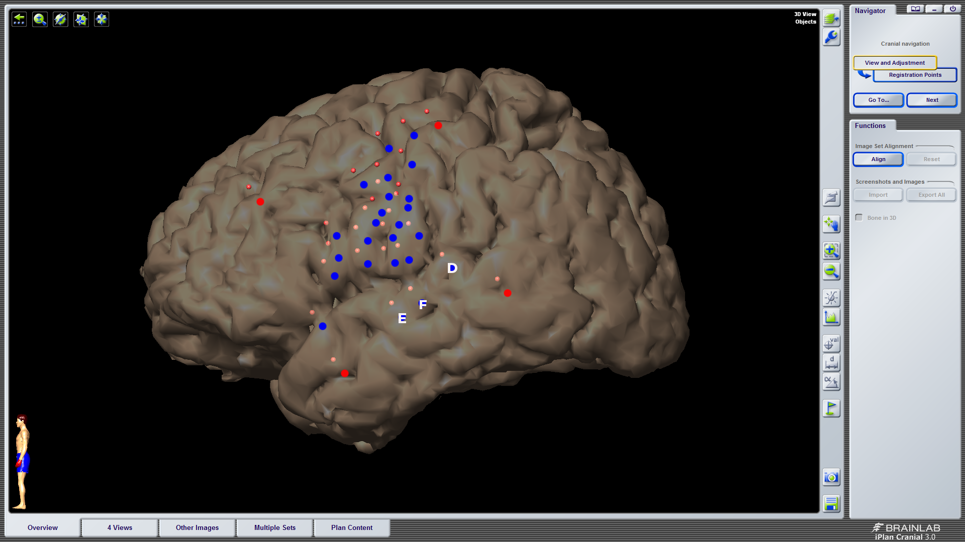

**SITES 'E' & 'F' collapsed**

1 trial w/ stimulation during target window only (1 trial w/ bleedover into buffer)

a. 1/1 trial caused error - classified as phonological, velocity -> muhgrasity (no error on bleedover trial)

2 trials w/ stimulation during buffer window only (1 trial w/ bleedover)

a. 0/2 trials caused error (no error during bleedover trial)

1 trial w/ stimulation during production window only

a. 1/1 trial caused error - classified as phonological, statistical -> suhdastruh

**SITE 'D'**

0 trials w/ stimulation during target window only

a. no errors

2 trials w/ stimulation during buffer window only

a. no errors

2 trials w/ stimulation during production window only (1 w/ partial stim during buffer window)

a. no errors

OF NOTE: this patient was very tearful throughout the procedure (labiality and pain seemed to be stimulation-related, perhaps given site of tumor location); there was no epilepsy team and during the probe list the patient stated that he felt an "aura", so he most likely was having a seizure and it may question some of his results during both sets of repetition data